LEPC Committee Meeting

Date: 08/21/2018 Meeting Type: [ X ] Regular / [ ] Special
Time: 06:00 pm.
Location: Vermilion County EMA (EOC/C-TAC) Information about this meeting Contact:

Objective(s): Informational updates, Required Annual LEPC Exercise
Jennifer Jenkins
Office Manager
Vermilion County Board
201 N Vermilion
Danville, IL 61832
217-554-6006
jjenkins@vercounty.org

Attendees: LEPC Committee Members and First Responder guests for exercise.

Committee Members Preparation:
Prior to meeting, Please review attached:
{LEPC Agenda Executive Briefing}
{New Location of Vermilion County EMA 201 N. Vermilion}

AGENDA
- Call to Order and Roll Call. ^{[Presenter: LEPC Chairman]}
- Adoption or Amendment to the Agenda. [Action Item] ^{[Presenter: LEPC Chairman]}
- Adoption or Amendment to the Minutes meeting dated 08/30/2017 [Action Item] ^{[Presenter: LEPC Chairman]}
- Audience Comments: ^{[Presenter: LEPC Chairman]}

[Old Business]

- Sub-Committee Reports [ None ]

[New Business]

- Review and Discuss any LEPC Informational Distributions since last meeting.
  - HAZMAT Incident Reports [Presenter: EMA Director, Ted Fisher]
- Review LEPC 2017 Annual Report. [Presenter: EMA Director, Ted Fisher]
- 2017 TIER II Report. [Presenter: EMA Director, Ted Fisher]
- LEPC Exercise [Presenter: EMA Chief Deputy, Russ Rudd]

- Executive Session [ ] Needed, [ X ] Not Needed
- Items of Information and Committee Concerns^{[Presenter: LEPC Chairman]}
- Adjournment^{[Presenter: LEPC Chairman]}
- LEPC Required Annual Exercise starts immediately after meeting

Other Notes and Attachments:
- LEPC Meeting Minutes 08/30/2017

- Supporting Documents will be distributed at the meeting.
- LEPC Agenda, Executive Briefing.

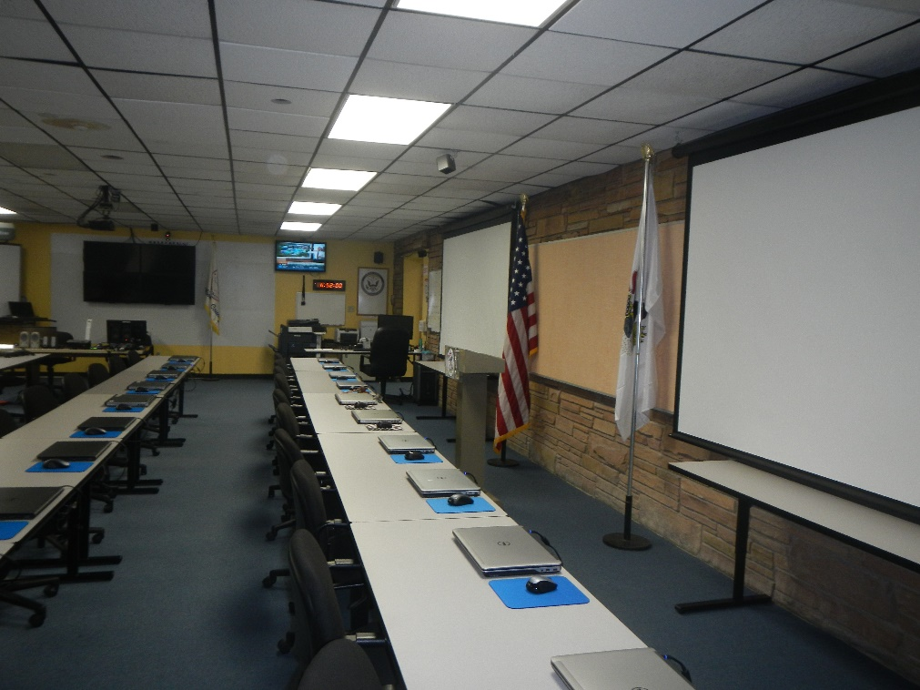

LOCAL EMERGENCY PLANNING COMMITTEE (LEPC)

This committee, committee members and its actions are subject to:
Illinois Open Meetings Act (OMA) and the Freedom of Information Act (FOIA).

LEPC Meeting Agenda
Executive Briefing

Date: 08/21/2018
Time: 06:00 pm.
Location: Vermilion County EMA (EOC/C-TAC)

Agenda Item #6: [Presenter: EMA Director, Ted Fisher]

Review and discuss HAZMAT incidents since last meeting (08/30/2017)

Agenda Item #7: [Presenter: EMA Director, Ted Fisher]

Review and discuss LEPC 2017 Annual Report that is submitted to the State.

Agenda Item #8: [Presenter: EMA Director, Ted Fisher]

Update on the 2018 TIER II billings and the amount paid.

Agenda Item #9: [Presenter: EMA Chief Deputy, Russ Rudd]

Conduct a required annual LEPC exercise (tabletop) Guests will attend to facilitate exercise.

Contact Information:

Ted Fisher, Director
Vermilion County Emergency Management Agency
State of Illinois
County of Vermilion
Danville, IL 61832
Office: (217)443-6010
201 N. Vermilion
Primary cell: (217)304-2152
email: tedf@vercomis.org

NEW Location of Vermilion County EMA:
Vermilion County Administration Building
201 N. Vermilion
Danville, IL 61832
Lower Level
217-443-6010
